Short description: A small calculator application. The calculator is intended to minimize the number of buttons, while also incorporating gestures for various functions, such as:

* Equals: swipe up
* Add: swipe right
* Subtract swipe left
* Clear: swipe down

There will also be a “history” display option that allows the user to view previously entered calculations, as usually seen with standard graphing calculators.

3+ drawings:

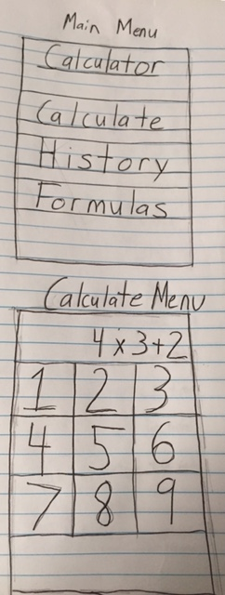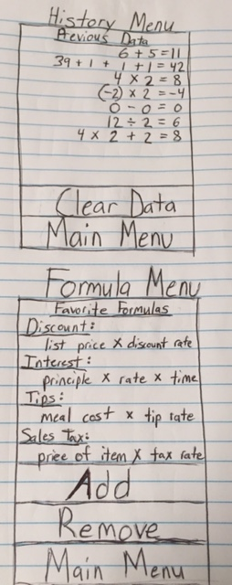

How to fulfill 9 criteria:

1. Images, including an app icon
   1. A calculator app icon
   2. A calculator logo incorporated within the main menu
2. A minimum of 3 interfaces (which are controlled by separate view controllers)
   1. A basic main menu interface that is displayed when the user opens the app. This will display the option to either perform calculations or to view previous calculation data.
   2. A calculation display that will show the output, the buttons for the numbers, and a little “touchpad” area that allows the user to interact with by using gestures to perform the calculation functions.
   3. An interface that shows the previous calculations that have been performed. There is the option to clear the data, otherwise the data should be persistent when the app is terminated.
   4. An interface that allows one to view and add common formulas. This is also persistent.
3. At least two different gestures
   1. Equals: swipe up
   2. Add: swipe right
   3. Subtract swipe left
   4. Clear: swipe down
   5. Tap: return back to the main menu
4. At least one animation
   1. Sliding animations that are utilized when switching to different interfaces
5. At least one alert
   1. When adding formulas, an alert pops up to notify the user to enter the formula within a text-field.
6. You must obtain text input from the user via a text-field (which may be included in the alert)
   1. When adding formulas, an alert pops up to notify the user to enter the formula within a text-field.
7. You must save some part of the state of your app when the app is terminated and restore it the next time the app is launched
   1. Previous calculation data will be saved
   2. Common formulas will be saved
8. You must have at least one of the following views:
   1. Table view
   2. Scroll view
      1. The formula interface will be pre-populated with enough formulas to allow a scroll view to work.
9. You must have at least one of the following views:
   1. Button
      1. Used to navigate to different interfaces
      2. Used to choose the numbers that are desired for input
   2. Slider
   3. Picker